**Module –: Node - Web Development with Node**

Q1. What is Express.js?

Ans.

🡪Express.js is a web application framework for node.js. It provides various features that make web application development fast and easy which otherwise takes more times using only node.js.

🡪Express.js is based on the node.js middleware module called connect which in turn uses http module. So, any middleware which is based on connect will also work with express.js

To install express.js

npm install -g express

npm install express --save

Q2. Create localhost server using express.

Ans. var http = require('http');

http.createServer(function (req, res) {

    res.writeHead(200, {'Content-Type': 'text/plain'});

    res.end('Hello World!');

}).listen(8888);

Q3 . Create basic “Hello world” app using node and express

Ans: var http = require('http');

http.createServer(function (req, res) {

    res.writeHead(200, {'Content-Type': 'text/plain'});

    res.end('Hello World!');

}).listen(8888);

Q4. Create weather app.

i. Use Hbs.

ii. Get country ,state, city using api.

iii. Get weather data by city

ans.

🡪Index.js

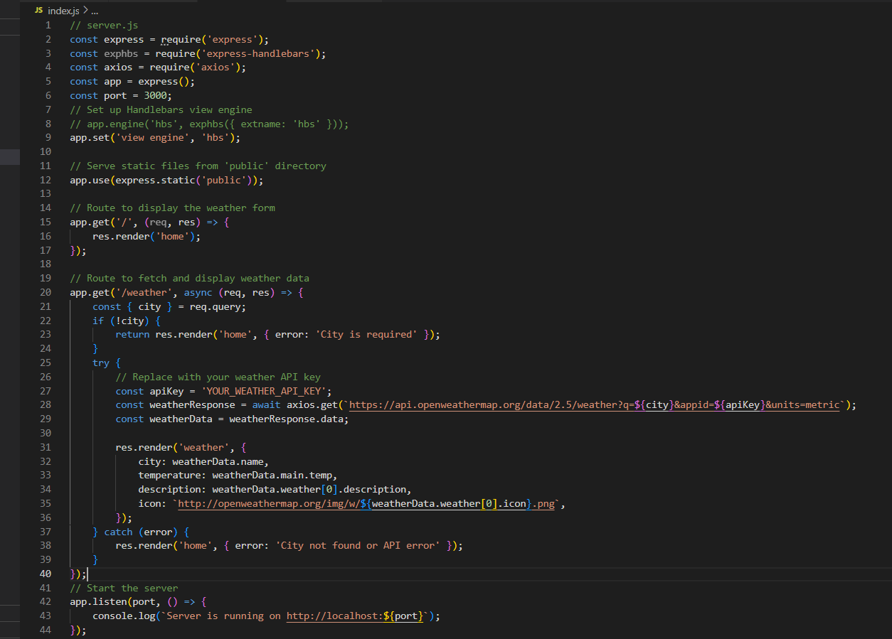

🡪home.hbs

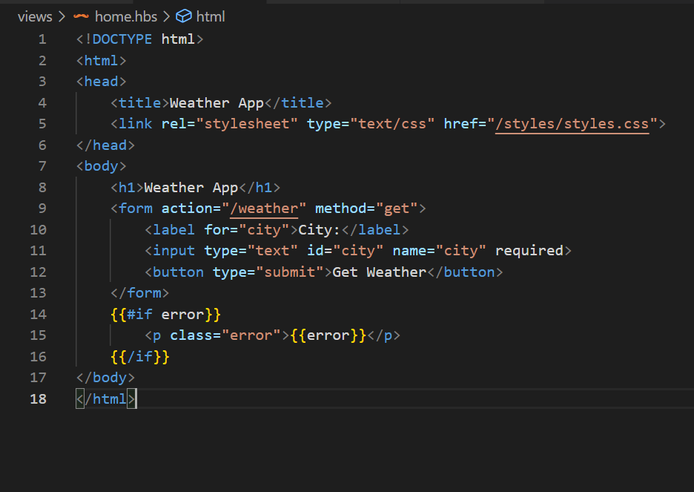

🡪weather .hbs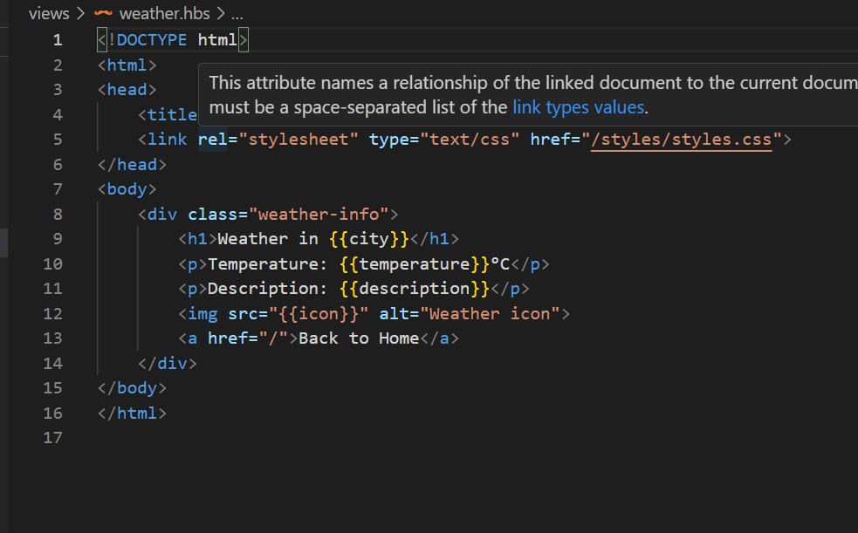

🡪output

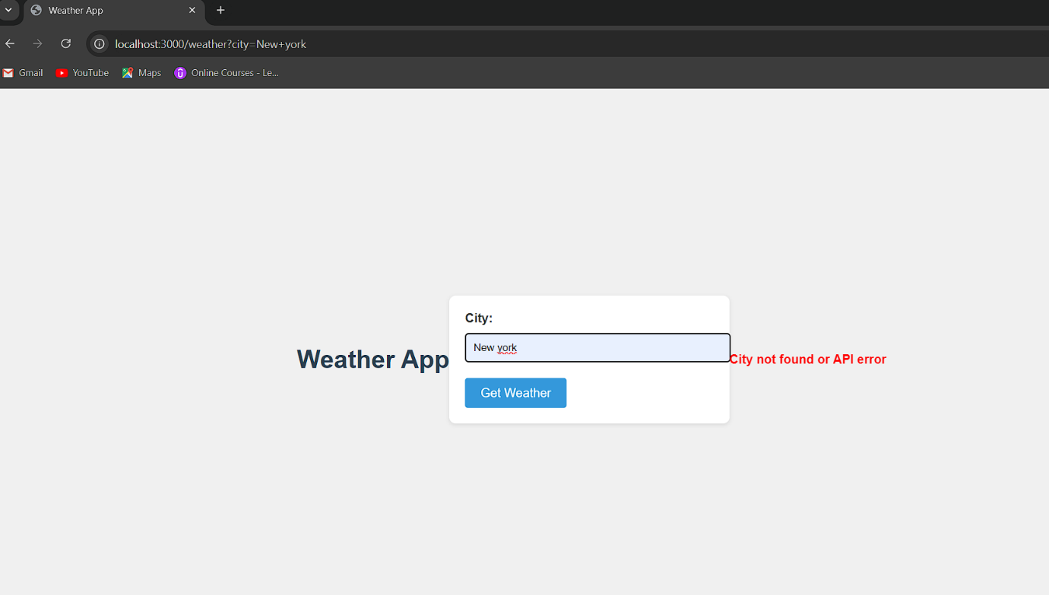

Q5. Create world clock app.

Ans. 🡪index.js

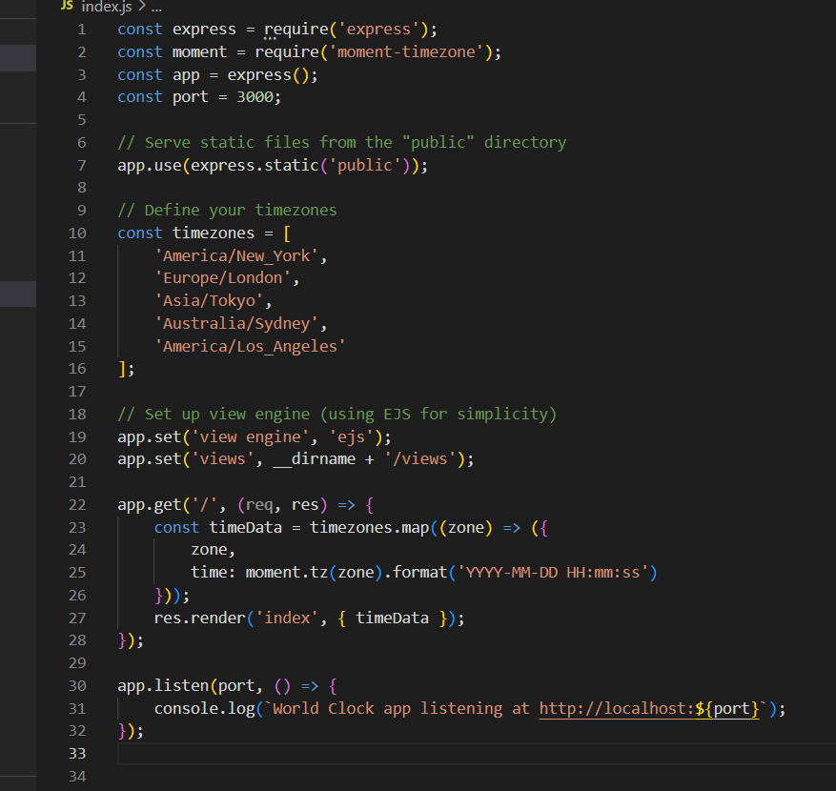

🡪index.ejs

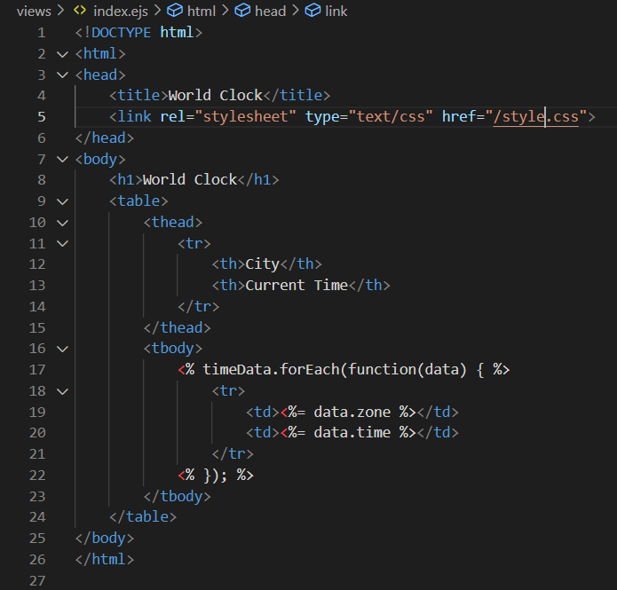

🡪output

